Task No & Title: Unit 1 | Unit Descriptor This unit defines the competency required to operate a personal computer, including starting the PC, logging in, using and understanding desktop icons and their links to underlying programs, navigating a directory structure, saving work, printing, system checks and closing down the PC. This unit is a prerequisite to starting the course and should be completed as soon as possible.
Title: | The Mouse
Suitable for Classes: | Certificate II in Information Technology
Area: | Technology & Enterprise
Teacher: | Mr Peter Faulks
Timeline | 1 Lesson  1
Date Due: | Today
Task Brief: | Answer all questions
Files Required | Computer Portfolio

Items highlighted in yellow are tasks for you to complete
Items in Purple are help tips

Certificate II in Information Technology

Unit | Number | Title | Type | Hours
01 | ICAU1128B | Operate personal computer | Pre | 20
02 | BSBCMN106A | Follow workplace safety procedures | Core | 10
03 | ICAD2012B | Design organisational documents using computing packages | Core | 40
04 | CAU2005B | Operate computer hardware | Core | 20
05 | ICAU2006B | Operate computing packages | Core | 60
06 | ICAU2013A | Intergrate Commercial computing packages | Core | 25
07 | ICAU2231B | Use computer operating system | Core | 20
08 | ICAW2001B | Work effectively in an IT environment | Core | 25
09 | ICAW2002B | Communicate in the workplace | Elective | 20
10 | ICAS2014B | Connect Hardware Peripherals | Elective | 25
11 | ICAU2007B | Maintenance of equipment and consumables | Elective | 15
12 | ICPMM263B | Access and use the internet | Elective | 20
13 | ICAW2011B | Work individually or as a team member | Elective | 20
14 | ICPMM321B | Capture a digital image | Elective | 30
 |  |  | TOTAL

Operate personal computer


If you want to practice on a mouse try this

http://www.mouseprogram.com/practice.html

Answer these questions.
- What is the purpose of a mouse?
Answer
- What two systems function in a mouse?
Answer

- What is the unit of measurement used by a mouse, and what is the smallest measurement?
Answer

- What software does the computer use to understand the signals coming from the mouse?
Answer

- list the steps you would take to change the mouse settings on a computer.
Answer

- Name two devices that can be featured on laptops instead of a mouse
Answer

Answer the following questions:
- What is the definition of a Peripheral?
Answer

- What does a typical computer system consist of?
Answer

- How many peripherals can you see on the computer in front of you? Name them.
Answer

- Where are peripherals connected?
Answer

- List the ESSENTIAL peripherals?
Answer

- List 4 OPTIONAL peripherals that could be used to extend the capabilities of a computer.
Answer

- What is the difference between INPUT and OUTPUT devices? Provide an OPTIONAL and ESSENTIAL device for each.
Answer

- What is a DEVICE DRIVER?
Answer

The Keyboard

Answer these questions.
- Why was the QWERTY keyboard designed with its particular layout?
Answer

- Where does the QWERT keyboard get its name?
Answer
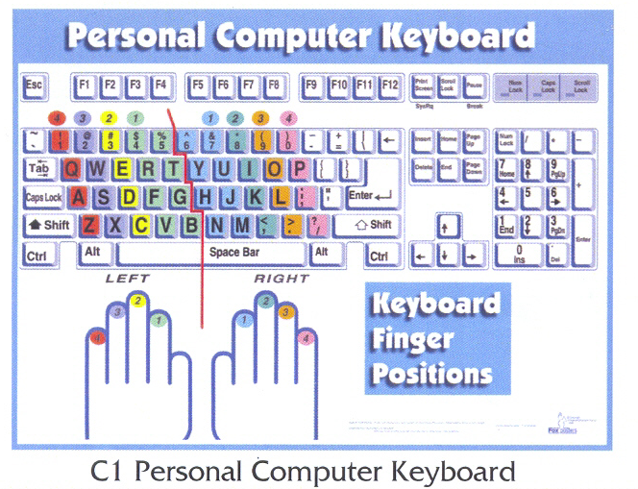
- Name the four main groups of keys found on the 102-key enhanced keyboard.
Answer

- CTRL, ALT and SHIFT keys are what type of keys?
Answer

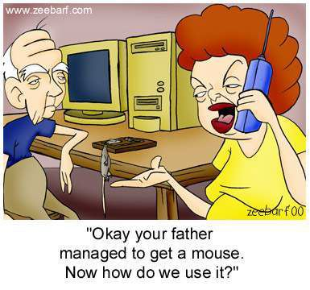
Test your MOUSE and KEYBOARD.
Create a Word document called Peripheral Test and for each write the following:-
- How you tested the device. (The process you followed)
- A brief report on the results of the test. (faults discovered, problems, etc)
- Recommendations (What needs to be done to restore device, if necessary)

ASSESSOR FEEDBACK FORM
Student Name:
Assessment Date/Due |  | Assessor’s Name: | Peter J Faulks
Training Package: | ICA05
Qualification: | ICA20105 Certificate II in Information Technology

FEEDBACK FOR FUTURE ACTION
Overall performance, gaps and feedback:

Assessment Record | Satisfactorily Completed
Task 1: Practical Activities | Yes | No
Task 2: Written Questions | Yes | No
Task 3: Observation | Yes | No

Is a reassessment required? Circle  Date of Reassessment if applicable: _____________________ | Satisfactorily Completed
   | Yes | No
Task 1: Practical Activities | Yes | No
Task 2: Written Questions | Yes | No
Task 3: Observation | Yes | No

Assessment of Competency completed: _____/_____/_____

Outcome: (Tick)
Competent |  | Not yet competent

Candidate Signature: | Date:
Assessor Signature: | Date:

Checklist of electronic, work and portfolio filing systems
01 ICAU1128B Operate personal computer
Name: | Competent | Yes | Not Yet

Section 1 Practical

Task Requirements
The task requires that you set up your electronic filing space, work folder and evidence portfolio in accordance with the following guidelines
Due Date
This task is to be submitted on 5 February 2011.
It is your responsibility to ensure that this task is submitted on time. If you are unable to submit this task on the specified date, it is your responsibility to see me to negotiate any extensions or any extra assistance that may be require.
Task Feedback
Your electronic filing system must contain the following (this must be evidenced through a print screen print out):

You must create a folder in your work space titled C2BSB.
Within that folder you are to create the following sub folders:

01 Operate personal computer
02 Follow workplace safety procedures
03 Design organisational documents using computing packages
04 Operate computer hardware
05 Operate computing packages
06 Integrate commercial computing packages
07 Use computer operating system
08 Work effectively in an IT environment
09 Communicate in the workplace
10 Connect hardware peripherals
11 Maintain equipment and consumables
12 Access and use the internet
13 Work individually or as a team member to achieve
organisational goals
14 Capture a digital image

- Your evidence portfolio (provided to you) must contain the following:
- Spine Label
- 5 file dividers with the following labels:
- Course Documents
- Term 1
- Term 2
- Term 3
- Student Assessment Record

- Your work folder (provided by you) must contain the following:
- A two ring binder.
- A cover page with your name.
- 18 File dividers with the following sections:

- Time Plans
- Term evidence records
- 01 Operate personal computer
- 02 Follow workplace safety procedures
- 03 Design organisational documents using computing packages
- 04 Operate computer hardware
- 05 Operate computing packages
- 06 Integrate commercial computing packages
- 07 Use computer operating system
- 08 Work effectively in an IT environment
- 09 Communicate in the workplace
- 10 Connect hardware peripherals
- 11 Maintain equipment and consumables
- 12 Access and use the internet
- 13 Work individually or as a team member to achieve organisational goals
- 14 Capture a digital image
- Reflection
- Homework

Insert screen shot here:
Teacher Comment & Signature

Student Comment and Signature

Parent Comment and Signature

